CRYPTO LENDING
WORKFLOW & SYSTEM DESIGN
Proposed LendFoundry-Style End-to-End Lending Journey

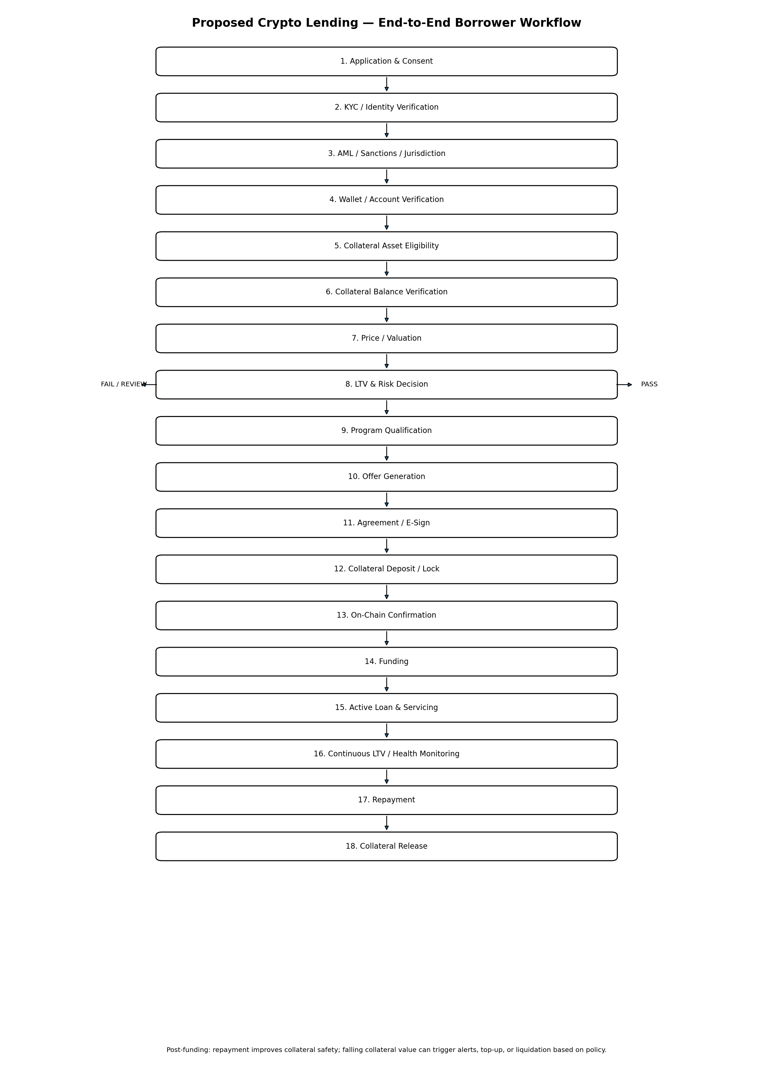
Purpose
This document translates a traditional LendFoundry-style lending journey into a proposed crypto-backed lending workflow. It is intended as a product/engineering discussion baseline, not a final legal, regulatory, custody, or protocol specification.

Document Contents
- 1. Executive Summary
- 2. Scope and Design Assumptions
- 3. Crypto Lending in Simple Terms
- 4. Traditional LendFoundry vs Crypto Lending
- 5. Detailed End-to-End Workflow
- 6. Detailed Step-by-Step Functional Requirements
- 7. Decision Rules and Key Metrics
- 8. Custodial vs Non-Custodial Design
- 9. Third-Party Integrations
- 10. High-Level System Architecture
- 11. Loan Servicing, Monitoring and Liquidation
- 12. QA / Automation Test Strategy
- 13. Data Objects and Suggested Statuses
- 14. Risks, Dependencies and Open Decisions
- 15. Recommended MVP Scope
- 16. Reference Notes

1. Executive Summary
A crypto-backed lending platform allows a borrower to obtain liquidity without necessarily selling the crypto asset they own. The crypto asset is pledged as collateral; the platform determines borrowing capacity from the collateral value, risk parameters and product rules. In decentralized lending, over-collateralization, LTV/health metrics, interest accrual and liquidation are core mechanisms. Aave's current documentation, for example, describes supply-and-borrow markets where borrowers lock collateral, borrow against it, accrue interest and can be liquidated when the position becomes unhealthy. These mechanics are useful as an industry reference, but they are not a requirement to copy Aave's implementation.
For a LendFoundry-style product, the recommended conceptual model is to retain the familiar loan lifecycle—application, identity/compliance, eligibility, offer, agreement, funding, servicing and completion—while adding crypto-native stages: wallet/account verification, asset eligibility, collateral balance verification, market valuation, LTV/risk checks, collateral locking, blockchain confirmation, continuous monitoring and liquidation handling.
Key difference from traditional lending
Traditional underwriting heavily evaluates borrower repayment capacity using credit, income and DTI. Crypto-backed lending can shift a substantial part of the risk decision toward the value and quality of collateral, its liquidity, LTV, price volatility and liquidation mechanics. Credit/income checks may still be required depending on the product and jurisdiction.

2. Scope and Design Assumptions
- Primary scenario: crypto-backed lending in which a borrower pledges a supported digital asset and receives a loan asset such as a stablecoin or, where supported, fiat.
- The workflow is designed as a conceptual extension of a LendFoundry-style LOS and is intentionally vendor-neutral.
- KYC/AML, sanctions, custody, payments and blockchain infrastructure are treated as external capabilities that may be integrated rather than rebuilt inside the LOS.
- The design supports both custodial and non-custodial variants; the exact choice must be a product/legal/compliance decision.
- The document uses illustrative thresholds and examples only. Production values such as maximum LTV, liquidation threshold, interest rate and supported assets must be configured through approved risk policy.
- Regulatory obligations vary by jurisdiction. FATF guidance treats virtual-asset businesses subject to its standards as requiring risk-based controls including customer due diligence, record keeping and suspicious-transaction reporting; local law must be assessed separately.

3. Crypto Lending in Simple Terms
A simple example:
Item | Example
Borrower | Alice
Collateral | $100,000 of ETH
Requested loan | $50,000
Initial LTV | 50%
Loan asset | USDC or another approved asset
Core risk | ETH price falls and collateral becomes insufficient
The borrower is not simply handed money because they own crypto. The platform must establish identity/compliance, verify the collateral, value it, determine how much can be borrowed, document the agreement, ensure the collateral is actually secured, fund the loan, and then continuously monitor the position.

4. Traditional LendFoundry vs Crypto Lending
Traditional LendFoundry Step | Crypto Lending Equivalent | Main Question
Application | Application + wallet/asset information | What does the borrower want and what collateral will support it?
Soft Pull / FICO | Pre-risk and collateral eligibility checks | Does the applicant/asset pass initial policy?
Citizenship verification | KYC + jurisdiction eligibility | Can the platform legally/on-policy serve this person?
Plaid identity | KYC/identity provider | Is the borrower really who they claim to be?
Program qualification | Product + collateral program qualification | Which loan product and collateral rules apply?
Hard pull | Optional credit/risk check | Is credit data required by this product?
Initial DTI | Initial LTV / collateral capacity | How much can safely be borrowed against collateral?
Income verification | Optional income/source-of-funds verification | Is repayment capacity independently required?
Final DTI | Final LTV / final collateral validation | Are final underwriting conditions satisfied?
Offer | Offer | What amount, rate, term, collateral and risk parameters apply?
Document signing | Loan/collateral agreements + e-sign | Has the borrower accepted the legal terms?
Completion certificate | Loan activation / collateral confirmation | Are all pre-funding conditions complete?
Funding | Stablecoin/fiat funding | Can the approved loan be disbursed?
— | Continuous collateral monitoring | Is the position still safe?
— | Top-up / repayment / liquidation | What happens if collateral value deteriorates?

5. Detailed End-to-End Workflow

1. Application & Consent
Collect borrower identity, requested loan amount, loan asset/currency, collateral asset, wallet/account details, purpose where required, and required consents. Create a unique application/loan application ID.
Decision / outcome: PASS: required fields valid and application created. FAIL: missing/invalid information. REVIEW: policy requires manual intervention.

2. KYC / Identity Verification
Verify government ID, identity attributes and, where applicable, liveness/address information using an approved KYC provider. Persist provider reference and result.
Decision / outcome: PASS: verified. FAIL: verification rejected. REVIEW: provider requests manual review.

3. AML / Sanctions / Jurisdiction
Run customer screening and applicable risk checks. Assess jurisdiction eligibility and any prohibited/restricted conditions. Blockchain/address screening may be included here or later.
Decision / outcome: PASS: allowed. FAIL: prohibited/restricted. REVIEW: ambiguous/high-risk result.

4. Wallet / Account Verification
For non-custodial flows, connect or verify the user's wallet and establish that the user can authorize the relevant transaction. For custodial flows, create or link a custodial account.
Decision / outcome: PASS: wallet/account verified. FAIL: unsupported network, invalid address, or ownership/control cannot be established.

5. Collateral Asset Eligibility
Determine whether the collateral asset, chain/network and token contract are approved. Apply asset-specific risk parameters such as maximum LTV, liquidation threshold, debt ceiling and permitted loan assets.
Decision / outcome: PASS: asset supported. FAIL: unsupported asset/network/contract or policy restriction.

6. Collateral Balance Verification
Read blockchain/custody balance and confirm that the borrower has sufficient eligible collateral. Record asset quantity, wallet/account and verification timestamp.
Decision / outcome: PASS: required quantity available. FAIL: insufficient/unavailable balance.

7. Price / Valuation
Obtain an approved market price and calculate collateral value. Use a defined price source/oracle and freshness/staleness controls. Record price, timestamp and valuation method.
Decision / outcome: PASS: fresh and valid price. FAIL: stale/missing/outlier price; position should not be funded using invalid valuation.

8. LTV & Risk Decision
Calculate requested and final LTV. Apply collateral-specific limits, concentration rules, exposure limits, volatility buffers, borrower risk rules and any additional underwriting requirements.
Decision / outcome: PASS: within policy. FAIL: LTV/exposure exceeds policy. REVIEW: borderline or exception case.

9. Program Qualification
Select the eligible loan program based on collateral, loan asset, geography, customer segment, term, LTV and risk policy. Determine rate, fees, repayment structure and monitoring parameters.
Decision / outcome: PASS: eligible program found. FAIL: no program matches.

10. Offer Generation
Create the formal offer containing loan amount, asset/currency, rate, term, collateral requirement, LTV, fees, repayment schedule, liquidation-related disclosures and key conditions.
Decision / outcome: PASS: offer generated. EXPIRED: offer not accepted within validity period.

11. Agreement / E-Sign
Present loan agreement, collateral terms, disclosures and applicable consents. Capture electronic signature and agreement version.
Decision / outcome: PASS: signed. FAIL: declined/expired/incomplete.

12. Collateral Deposit / Lock
Transfer or pledge the required collateral. In a custodial design, collateral moves into/under the approved custodian's control. In a non-custodial design, the borrower authorizes the smart contract to receive/lock collateral.
Decision / outcome: PASS: collateral received/locked. FAIL: transaction rejected, insufficient gas, wrong asset/address or insufficient amount.

13. On-Chain Confirmation
Wait for the required blockchain confirmations or equivalent custody confirmation. Reconcile expected and actual collateral quantity and ownership/control state.
Decision / outcome: PASS: confirmed. PENDING: awaiting confirmations. FAIL: reverted/failed/reorg/irreconcilable.

14. Funding
Disburse the approved loan asset after all funding gates are satisfied. Record transaction/transfer ID and funding timestamp.
Decision / outcome: PASS: funded. FAIL: liquidity/payment/blockchain issue.

15. Active Loan & Servicing
Create/activate loan, accrue interest according to policy, maintain repayment schedule, calculate outstanding principal/interest/fees and expose borrower statements.
Decision / outcome: ACTIVE, DELINQUENT, PAID-OFF, DEFAULTED or other approved servicing statuses.

16. Continuous LTV / Health Monitoring
Revalue collateral as prices change. Recalculate LTV/health metrics. Generate warning, top-up, repayment or liquidation actions based on configured thresholds.
Decision / outcome: HEALTHY: continue. WARNING: notify. ACTION REQUIRED: top-up/repay. LIQUIDATION ELIGIBLE: initiate permitted liquidation path.

17. Repayment
Accept principal, accrued interest and fees. Reconcile payment and update outstanding balance. Support partial or full repayment according to product rules.
Decision / outcome: PARTIAL: continue monitoring. FULL: proceed to release.

18. Collateral Release
After the loan is fully satisfied and all release conditions are met, release/transfer the collateral back to the borrower or designated destination.
Decision / outcome: PASS: collateral released and reconciled. FAIL: release transaction/custody exception requiring resolution.

6. Detailed Functional Requirements by Stage

Application & Borrower Profile
- Capture unique application ID and customer ID.
- Capture requested amount, loan asset/currency, term and repayment preference.
- Capture collateral asset, network/chain and wallet or custodial account reference.
- Capture consent to KYC/AML, credit checks where applicable, blockchain/custody checks and electronic communications.FAIL: release transaction/custody exception requiring resolution.
- Prevent duplicate or conflicting active applications according to product policy.

Identity, Compliance & Risk
- Store KYC provider result, reference ID, timestamp and verification status.
- Support sanctions/AML screening and risk outcomes.
- Support manual review queues and reason codes.
- Do not allow funding while mandatory compliance checks are unresolved.
- Apply jurisdiction-specific eligibility and product restrictions.

Collateral
- Maintain approved collateral asset master data.
- Maintain supported network/chain and token contract identifiers.
- Verify balance and ownership/control using custody records or blockchain data.
- Record quantity, valuation, price source, price timestamp and collateral value.
- Prevent unsupported or stale valuations from being used for funding.

LTV / Risk Engine
- Calculate initial LTV = loan value / eligible collateral value × 100.
- Maintain asset-specific maximum LTV.
- Maintain liquidation threshold and any warning threshold.
- Apply exposure/concentration/debt-ceiling rules where applicable.
- Recalculate after collateral price, debt balance or collateral quantity changes.
- Keep an audit trail of every material risk calculation.

Offer & Contracting
- Generate a versioned offer.
- Show collateral requirements and risk disclosures.
- Capture acceptance and e-signature.
- Freeze material terms between approval and funding unless an explicit re-underwriting event occurs.

Funding & Servicing
- Require collateral confirmation before funding.
- Record funding transaction/transfer ID.
- Accrue interest according to the configured rate model.
- Track principal, interest, fees, payments and outstanding balance.
- Support reconciliation between LOS records and on-chain/custodian records.

Monitoring & Liquidation
- Continuously or periodically update collateral valuation according to the product's risk requirements.
- Trigger warnings before liquidation threshold where policy defines a buffer.
- Support collateral top-up and partial repayment.
- If liquidation conditions are met, execute the approved liquidation process and record all transactions.
- Reconcile post-liquidation debt, collateral and fees.

7. Decision Rules and Key Metrics

7.1 LTV
Illustrative formula: LTV (%) = Loan Value ÷ Eligible Collateral Value × 100.
Example | Value
Collateral | $100,000
Requested loan | $50,000
LTV | 50%
Illustrative max initial LTV | 50%
Decision | Passes initial LTV rule
A real protocol may use additional health metrics rather than LTV alone. Aave, for example, uses a Health Factor derived from collateral value, liquidation thresholds and borrow value; a position becomes eligible for liquidation when the Health Factor falls below 1. citeturn0search5turn0search3

7.2 Health / Liquidation Concept
A production design should distinguish at least three levels: a healthy operating range, a warning/action range, and a liquidation-eligible range. The exact thresholds are asset- and product-specific and should be maintained as configuration rather than hard-coded into UI logic.
State | Meaning | Typical System Action
Healthy | Collateral comfortably supports debt | Continue servicing
Warning | Risk buffer is shrinking | Notify borrower; encourage top-up/repayment
Action Required | Policy-defined risk threshold reached | Require top-up/repayment or restrict further borrowing
Liquidation Eligible | Position meets liquidation condition | Initiate approved liquidation mechanism
Closed | Debt fully repaid/settled | Release collateral and close loan

8. Custodial vs Non-Custodial Design
Area | Custodial | Non-Custodial / Smart-Contract-Based
Asset control | Custodian/platform controls custody under the agreed legal structure. | User controls wallet keys; collateral is typically controlled/locked by smart contracts once deposited.
Wallet UX | May be abstracted from user. | User generally connects/signs with a self-custodial wallet.
Collateral release | Custodian executes release. | Smart contract/user-authorized transaction executes release.
Liquidation | Platform/custodian may execute according to contractual rules. | Protocol/smart contract and authorized liquidation actors execute according to on-chain rules.
Main operational risk | Custodian/counterparty/key-management risk. | Smart-contract, oracle, wallet/key and blockchain execution risk.
LOS integration | Custody account + transfer/reconciliation APIs. | Wallet + blockchain RPC + smart contract + transaction monitoring.
Fit with traditional LOS | Generally more familiar operational model. | More blockchain-native and technically complex.
Aave is an example of a non-custodial design: users interact with smart contracts using self-custodial wallets, and supplied collateral is used to support borrowing. This is an industry reference, not a recommendation that the proposed product must use Aave. citeturn0search1turn0search2

9. Third-Party Integrations
Integration Category | Purpose | Required for MVP? | Notes
KYC / Identity | ID verification, liveness, identity attributes | Usually Yes | Provider depends on target geography.
AML / Sanctions | Customer and potentially wallet screening | Usually Yes | Compliance design must be jurisdiction-specific.
Blockchain RPC / Node | Read chain state and submit/track transactions | Yes for on-chain | Examples include infrastructure providers such as Alchemy, Infura or QuickNode; provider selection is an architecture decision.
Wallet | Connect/sign transactions in non-custodial flow | Non-custodial: Yes | Wallet compatibility must be defined by chain.
Custodian | Hold/control collateral | Custodial: Yes | Requires custody/legal/compliance review.
Price Oracle / Market Data | Collateral valuation and risk monitoring | Yes for collateralized risk | Must have freshness/staleness and fallback controls.
Smart Contracts | Collateral lock, borrow/repay/release/liquidation logic | On-chain design: Yes | May be internally developed, externally audited and deployed on the chosen chain.
E-sign | Loan agreement acceptance | Product dependent | Traditional LOS pattern.
Payment / Fiat Rail | Fiat funding or repayment | Only if fiat | Not required for a pure crypto-to-crypto product.
Notifications | KYC status, offer, LTV warnings, repayment alerts | Recommended | Email/SMS/push provider.
Blockchain Analytics | Address/transaction risk intelligence | Recommended / policy dependent | Useful for AML and source-of-funds risk controls.

10. High-Level System Architecture
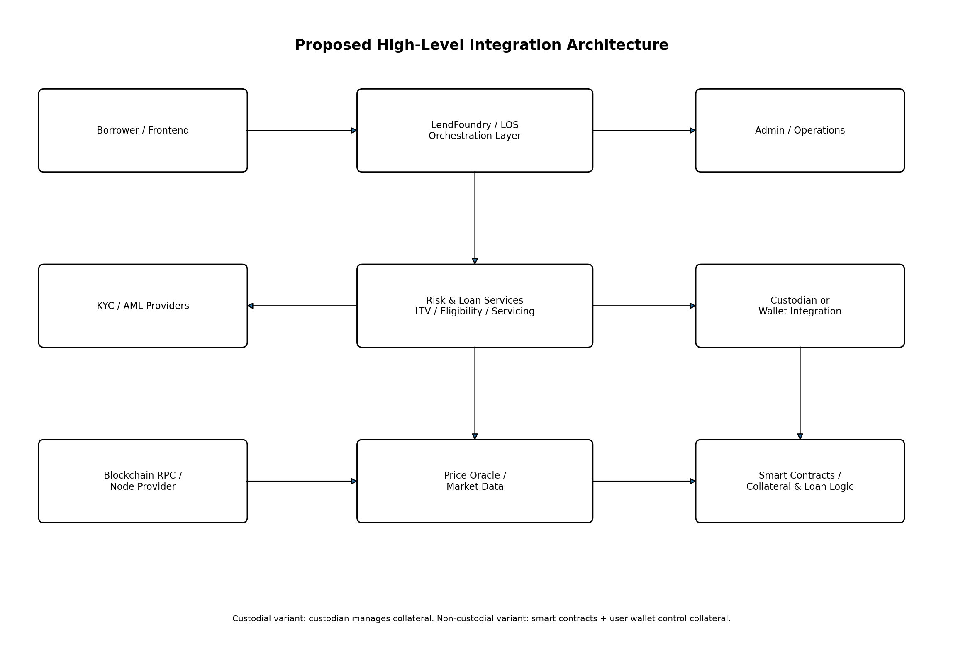
The LOS should remain the orchestration and system-of-record layer for the customer/loan lifecycle, while blockchain-specific services handle wallet, transaction, collateral and smart-contract concerns. The exact boundary should be decided during system design.

11. Loan Servicing, Monitoring and Liquidation
Unlike a traditional loan where underwriting is often concentrated around origination and servicing follows a scheduled payment calendar, crypto-backed lending requires ongoing collateral-risk monitoring. Aave documentation illustrates this pattern: collateral value and debt change over time, the position's health changes with market prices and accrued interest, and an unhealthy position can become liquidatable. citeturn0search3turn0search5
- Revalue collateral using approved price data.
- Recalculate debt and accrued interest.
- Calculate LTV/health metrics.
- Compare metrics with warning and liquidation thresholds.
- If warning: notify borrower and expose top-up/repayment actions.
- If action threshold: apply product restrictions and/or require remediation.
- If liquidation-eligible: execute the approved liquidation mechanism.
- Reconcile debt, collateral, fees and transaction records.
- Close the position when debt is satisfied and release remaining collateral.

Liquidation is not merely a UI status
It is an operational and technical process involving price data, risk calculations, transaction execution, collateral transfer/sale, debt settlement and reconciliation. For a non-custodial protocol, liquidation can be permissionless or handled by defined actors; Aave, for example, allows liquidators to repay eligible debt and receive collateral subject to protocol rules. citeturn0search4turn0search5

13. Data Objects and Suggested Statuses
Object | Important Fields | Suggested Statuses
Application | applicationId, customerId, requestedAmount, loanAsset, collateralAsset, walletRef | DRAFT, SUBMITTED, IN_REVIEW, APPROVED, DECLINED
KYC Check | provider, referenceId, result, timestamp, reason | PENDING, PASS, FAIL, REVIEW
Collateral Position | asset, network, quantity, value, price, priceTimestamp, wallet/custodyRef | PENDING, VERIFIED, LOCKED, RELEASED, LIQUIDATED
Loan | loanId, principal, rate, term, LTV, threshold, balance | APPROVED, FUNDED, ACTIVE, DELINQUENT, LIQUIDATION_ELIGIBLE, PAID_OFF, CLOSED
Blockchain Transaction | txHash, chainId, from, to, asset, amount, confirmations | SUBMITTED, PENDING, CONFIRMED, FAILED, REVERTED
Risk Decision | policyVersion, LTV, exposure, assetRisk, decision, reason | PASS, FAIL, REVIEW

14. Risks, Dependencies and Open Decisions
Topic | Why It Matters | Decision Needed
Regulatory model | Crypto lending/custody obligations vary by jurisdiction. | Target countries, licenses/registrations, compliance ownership.
Custody model | Changes wallet, collateral, liquidation and operational architecture. | Custodial, non-custodial or hybrid.
Supported assets | Determines price feeds, risk parameters and liquidity. | Initial asset list and network list.
Loan denomination | Changes funding/payment integrations. | Stablecoin, fiat or both.
Price source | Incorrect/stale pricing can cause incorrect LTV/liquidation. | Primary oracle + fallback + freshness policy.
Risk parameters | Controls borrower capacity and liquidation exposure. | Max LTV, warning threshold, liquidation threshold, caps.
Smart-contract ownership | Security and upgrade authority affect product risk. | Internal development vs protocol integration; audit requirements.
Liquidity source | Borrowing requires available funds or minting mechanism. | Treasury, liquidity pool, external protocol, or other source.
Liquidation model | Determines how bad debt and collateral sales are handled. | Internal service, custodian, external liquidators, smart contract.
Fiat rails | Required if loan is disbursed/repayed in fiat. | Bank/payment provider and reconciliation model.

15. Recommended MVP Scope
For an initial implementation, avoid supporting every crypto asset and every possible loan structure. A controlled MVP could be:
- One target jurisdiction and clearly defined compliance model.
- One blockchain network.
- One or two highly liquid collateral assets.
- One loan asset, preferably a clearly defined stablecoin or controlled fiat route.
- KYC + AML/sanctions integration.
- Wallet or custody integration, depending on selected model.
- Single price/oracle source plus defined fallback behavior.
- Simple overcollateralized LTV model.
- Offer + e-sign + funding.
- Repayment and collateral release.
- Warning and liquidation workflow.
- Full audit trail and reconciliation.
- Automated QA coverage for happy path, negative paths, price movement, transaction failures and liquidation states.
Recommended product decision sequence
1) Select jurisdiction/compliance model → 2) Select custodial vs non-custodial → 3) Select chain → 4) Select collateral/loan assets → 5) Define risk parameters → 6) Define liquidity/funding model → 7) Define smart-contract/custody architecture → 8) Select integrations → 9) Build LOS workflow and QA automation.

16. Reference Notes
The following references were used to ground the conceptual workflow in current industry mechanics and compliance context:
- Aave Protocol Documentation — Aave 101: supply/borrow, self-custody, overcollateralization and liquidations. https://www.aave.com/docs/aave-101
- Aave Protocol Documentation — Aave V3 Overview: LTV, Health Factor, liquidation and non-custodial architecture. https://www.aave.com/docs/aave-v3/overview
- Aave Help — Borrow Tokens: connect wallet, review LTV/liquidation parameters, confirm borrow and monitor Health Factor. https://aave.com/help/borrowing/borrow-tokens
- Aave Help — Health Factor & Liquidations: health-factor mechanics and liquidation process. https://aave.com/help/borrowing/liquidations
- FATF — Virtual Assets: risk-based AML/CFT expectations for virtual assets and VASPs. https://www.fatf-gafi.org/en/publications/Virtualassets/Virtual-assets-fatf-standards.html
- FATF — Seventh Targeted Update on Virtual Assets/VASPs (2026): current implementation update. https://www.fatf-gafi.org/en/publications/Fatfrecommendations/targeted-updated-virtualassets-vasps-2026.html

END OF DOCUMENT

